Combining Collaborative & Proactive Solutions and
Positive Behavior Interventions & Supports:
Recommendations for Schools Engaged in Transforming Disciplinary Practices

Kelly Sarah
School Counselor, Fond du Lac School District
Chegwin Elementary School
Fond du Lac, Wisconsin

Rachel Polacek
School Psychologist, The School District of North Fond du Lac
Friendship Learning Center
North Fond du Lac, Wisconsin

Ross W. Greene, Ph.D.
Department of Psychology, Virginia Tech
Faculty of Science, University of Technology Sydney

UNDER REVIEW…PLEASE DO NOT CITE, DISTRIBUTE, OR DUPLICATE
WITHOUT PERMISSION OF THE THIRD AUTHOR

Positive Behavior Interventions and Supports (PBIS) has become a ubiquitous (and sometimes mandated) approach to structuring the management of children’s behavior in schools, especially in the United States. PBIS provides a multi-tiered system of support to address students’ academic, social, emotional and behavioral needs. The model provides clear behavioral expectations (e.g., be respectful, be kind, be safe) for all students, and involves the teaching and reteaching of these expectations and the use of rewards to encourage positive behaviors. It also emphasizes the development and teaching of predictable classroom routines. PBIS operates on the belief that appropriate behavior can be taught to all students. It is also grounded in the belief that decision-making about students’ needs and interventions should be based on data. Although its effects on academic achievement are equivocal (Gage, Sugai, Lewis, & Brzozowy, 2015), a variety of studies have supported the effectiveness of PBIS in improving student behavior (e.g., Bradshaw, Koth, Thornton, & Leaf, 2009; Waasdorp, Bradshaw, & Leaf, 2012).

While there are notable benefits to data-based decision making, predictable routines, and having clear, positive behavioral expectations for students, the model is not without its detractors (e.g., Hassiotis et al. 2018; Wilson, 2015; Hunsaker, 2018). Though its originators maintain that PBIS is not a specific program or curriculum but instead a multitiered framework for organizing and achieving capacity to implement effective academic and behavioral practices (Sugai & Horner, 2020), its rooting in applied behavior analysis (see Dunlap, Carr, Horner, Zarcone, & Schwartz, 2008) drives many of the perceived practical and theoretical shortcomings of the framework. For example, in its reliance on rewards to encourage positive behavior, PBIS has been criticized for promoting extrinsic rather than intrinsic motivation (e.g., Kohn, 1999). Although it emphasizes rewards rather than punishment, PBIS has still been characterized as a unilateral, adult-driven model of intervention that may promote and maintain a power dynamic that is typical of traditional, punitive systems of school discipline and viewed by many as particularly counterproductive for the students who are the most frequent recipients of such discipline (Wilson, 2015). Along these lines, it has been suggested that PBIS has not been transformative enough to significantly curtail such discipline in many schools (Greene, 2008), perhaps due, in part, to the fact that it is more difficult to implement at Tiers 2 and 3 than at Tier 1 (Sugai & Horner 2020). It has been suggested that, in emphasizing overt behavior as the primary focal point of intervention, PBIS may overlook the academic and social expectations students are having difficulty meeting that are precipitating those behaviors (Greene, 2008).

In an effort to mitigate these perceived shortcomings, many schools have implemented other models of intervention within the organizational structure of PBIS. One such model is Collaborative & Proactive Solutions (CPS; Greene, 2008).

Collaborative & Proactive Solutions (CPS)

CPS is a psychosocial treatment model for behaviorally challenging youth first articulated in published form in 1998 in the book The Explosive Child (Greene, 1998) and later in books describing the application of the model in schools (Lost at School; Greene, 2008, 2014, 2020; Lost & Found, Greene, 2016, 2021). Over the past 20 years, the CPS model has been applied and studied in a diverse array of contexts, including families, general and special education schools, inpatient psychiatric units, and residential and juvenile detention facilities (Greene & Winkler, 2018), and with students of highly diverse cultural and ethnic backgrounds. The model is recognized as an evidence-based intervention (Greene & Winkler, 2019).

The CPS approach emanates from the same broad social learning theoretical foundations as other well-established forms of psychosocial intervention for concerning behaviors. However, CPS represents a significant departure from these interventions. The CPS model relies heavily on the vast findings in neuropsychology delineating the executive, language processing, emotion regulation, adaptability, and social skills frequently found lagging in youth with social, emotional, and behavioral challenges. These lagging skills explain why some students respond so maladaptively to problems and frustrations. An important premise of the CPS model is that concerning behavior occurs in conditions in which students are having difficulty meeting specific expectations. These “unmet expectations” are referred to as “unsolved problems,” and the goal of intervention is to help caregivers and kids engage in collaborative and proactive efforts to solve those problems, thereby reducing or eliminating the concerning behavior they cause (Greene & Winkler, 2019). Thus, the CPS model does not focus on overt behaviors (and modifying them) but rather on the problems that are causing those behaviors (and solving them, collaboratively and proactively). In the CPS model, the function of concerning behavior is that it communicates that a student is having difficulty meeting a particular expectation. This applies both to “internalizing” and “externalizing” behaviors.

In schools, application of the CPS model involves two primary components: (1) moving away from assessment instrumentation focused primarily on quantifying overt behavior and toward instrumentation aimed at identifying a child’s lagging skills and unsolved problems, through use of an instrument called the Assessment of Lagging Skills and Unsolved Problems (ALSUP); and (2) engaging students in solving those problems collaboratively and proactively. An important premise of the model is that the person ideally suited for solving a given problem with a student is the person whose expectation the child is having difficulty meeting. If a student is having Difficulty completing the double-digit division problems on the worksheet in math, then the ideal person to solve that problem with the student is the math teacher. If a student is having Difficulty agreeing on the rules of the four-square game with Billy during recess, then the person who monitors recess is ideally suited to facilitate a solution to that problem. If -- because of the concerning behaviors that may arise when a student is having difficulty meeting one of these expectations -- the student is simply sent to the office or to a school counselor or school psychologist (who may know little about those problems and may therefore be ill-equipped to solve them independently), then the problems will remain unsolved and the behaviors being caused by those problems will persist.

The ALSUP (see Appendix A) helps caregivers view a student’s concerning behaviors through the prism of lagging skills rather than lagging motivation or faulty learning. Moreover, because caregivers are identifying unsolved problems proactively, those problems can be prioritized and solved proactively. Thus, the CPS model helps schools move away from intervention that is primarily reactive toward intervention that is almost exclusively proactive. In this regard, overt behavior is understood to be “late;” the unsolved problems that are causing those behaviors are “early.”

The problem-solving process -- known as Plan B -- involves three steps:

- the Empathy step, in which caregivers gather information from the student about his or her concern or perspective about a given unsolved problem, with a primary focus on what’s making it difficult for the student to meet a specific expectation
- the Define Adult Concerns step, in which caregivers articulate their concern or perspective on the same unsolved problem, with a primary focus on why it’s important that the expectation be met (health, learning, safety of the student and/or others)
- the Invitation step, in which the student and caregivers collaboratively arrive at a solution that addresses the concerns of both parties.

The CPS model has been shown not only to reduce challenging behaviors (on a par with traditional operant procedures) but also to solve the problems that are causing those behaviors, enhance the lagging skills that are contributing to those problems (Ollendick et al., 2015; Dedousis-Wallace et al., 2016), and improve communication and relationships between kids with behavioral challenges and their caregivers (Greene et al., 2004; Booker et al., 2016; see Greene & Winkler, 2019, for a summary of accumulated findings).

Implementing CPS Within a PBIS Structure

Can CPS and PBIS be implemented in combination? Are there structures of PBIS that can interfere with the implementation of CPS? Can PBIS evolve in response to these structural limitations? In the following pages, we describe how CPS has been infused into the three tiers of PBIS in two school systems in Wisconsin. In these school systems, the application of CPS is not limited to any single tier; CPS lives in all three tiers and is a universal intervention. The three tiers are viewed as fluid, in that students can fluctuate between tiers on a given day. Therefore, it may make little sense to prescribe interventions based on the tier that has been attached to a student. CPS is applied to any student who has an unsolved problem in these schools. However, because PBIS is structured around three tiers, the discussion below is oriented toward each tier.

Tier 1

PBIS outlines some key practices that should be in place as part of PBIS structures for schools at Tier One, including:

- School wide positive expectations and behaviors are defined and taught
- Procedures for establishing classroom expectations and routines are consistent with school wide expectations
- Continuum of Procedures for Encouraging Expected Behavior
- Continuum of Procedures for Discouraging Problem Behavior
- Procedures for Encouraging School- Family Partnerships
Our CPS/PBIS blended schools have clearly defined school-wide and classroom behavioral expectations. These behavioral expectations are taught as needed through traditional PBIS practices (behavioral lesson plans or cool tool videos, practice and review of expectations in classrooms, etc.). However, if a student continues to demonstrate concerning behaviors, those behaviors are not retaught, as we have found that most of the students can easily recite the behaviors they should and shouldn’t exhibit. Instead, we engage students and teachers in Plan B discussions with regard to the specific academic and social expectations that are precipitating those behaviors, often using the ALSUP as the means by which unsolved problems are identified.
Our initial efforts to move toward CPS began by exposing staff to resources offered by Brené Brown, including her book, Dare to Lead. Brown’s research on leadership, vulnerability, and shame set the stage for staff to embrace CPS. We felt this was an important place to start because changing our colleagues’ perceptions and attributions about behavior often requires us to have difficult conversations and become comfortable with the vulnerability many adults initially feel in collaborating with students on solving problems, as they often feel that they will lose authority or power in the process. We also found that these resources helped staff understand the importance of understanding students’ shame self-talk (e.g., “I’m just a bad kid”).
Plan B Progress Sheet
In the CPS model, an instrument called the Problem Solving Plan (see Appendix B) is used to document student and adult concerns and solutions. However, we found it necessary to use a separate form to document our Plan B discussions with students and teachers and to monitor ongoing progress, and created the Plan B Progress Sheet (see Appendix C). Our students and teachers know that when we have this sheet present for our sessions that we are in the problem solving “business.” We have received feedback that this sheet helps the kids and teachers feel important and that their concerns will be taken seriously. Indeed, after solving multiple problems with some of our students, they started requesting the “purple problem solving sheet.” When asked, “Why do you want a purple sheet?” the students would reply, “Because I have a problem and I need it, I have to solve it with my teacher.” It was powerful to see kids with multiple unsolved problems, who in the past had “armored up” and had been unreachable, finally start to advocate for themselves in a healthy way.

The Plan B Progress Sheet also helps our SEL teams keep track of progress with unsolved problems. We use the sheets to follow up with both the kids and teachers and are able to use the sheets to ask specific questions about whether solutions are working. If we learn that a solution isn’t working, we know that we will need to schedule another Plan B session with that student and teacher to discuss how the solution needs to be adjusted or changed. The new solutions are then recorded on the original Plan B Progress Sheet. Lastly, the Plan B Progress Sheet memorializes solutions and helps students and teachers feel a greater sense of accountability for the solutions they mutually agree upon.

Different data

One crucial change we initiated was to modify the behavioral data we collected on our students. It wasn’t possible to discard behavior reporting forms completely, but we modified the behavior reporting forms so that they provided information that would help pinpoint unsolved problems. The first significant change to the collection of Major and Minor behavior data began with gathering more specific information about when and where behaviors occurred, thereby helping us home in on the problems that are causing the behavior (rather than focusing solely on the behavior itself). We also eliminated the “Motivation” section of our behavior reporting form, as we felt it was unnecessary. Our schools operate under the “Kids do well if they can” lens of the CPS model, so we believe that the only reason students exhibit concerning behavior is to communicate that they’re having difficulty meeting a particular expectation. In other words, their behavior is simply communication; nothing more, nothing less. We also removed defiance, disrespect, and disruption from the form, as we believe that these terms are too subjective and culturally loaded.

We have found that the new data we collect is much more valuable to us than the data we collected in years prior. We are better able to identify students’ unsolved problems and the behavior forms better reflect our philosophy on behavior. One example of how these revised forms have helped, is when we have multiple referrals coming out of one classroom. For example, last school year we noticed that one classroom teacher had completed referrals on many students during math. Instead of doing Plan B with the eight students for whom we had received referrals, an SEL team member facilitated a group Plan B session with the entire class and the teacher. This teacher, with the SEL team member’s support, was able to be vulnerable with her students. She not only shared the concerns that she had with her students, but also listened to the concerns that her students had (many of which indicated concerns about low level of student engagement, poor transitions, confusion about content, etc.). This whole-class Plan B discussion led to the teacher reaching out to her colleagues for more information about a math workshop model. As a result, she was able to change her classroom instruction from more of a “sit and get” model to a workshop model. This change was completely out of the teacher’s comfort zone, but she was deeply committed to having a class with less disruptions and to increasing the connections between herself and her students. Had we merely gathered behavioral data on disruptions and disrespect as we had done in the past, this outcome would have been more difficult to achieve.

Tier 2

Tier 2 is an additional targeted layer of support that about 15 percent of students require. Tier 2 provides students with additional social skills training, emotional regulation strategies, or other behavior interventions, such as teaching and reteaching expectations. Additional Tier 2 interventions include check in/check out, social academic instructional groups, mentoring, and brief behavior intervention plans. While additional prompting and feedback is provided to students at the Tier 2 level, proactively understanding student and adult concerns is not part of the process. As such, prior to our implementation of CPS, we did not have the information we needed about what was making it hard for a student to meet a particular expectation. Furthermore, we did not clearly understand the concerns of the teacher as to how the problem is affecting the student and others. Through the use of Plan B, we now gather that information and are better able to work toward realistic and mutually satisfactory solutions.

As noted earlier, a defining feature of PBIS is data-based decision making. It is critical to note that we removed “data rules” dictating when and what kind of support are provided. We no longer need to “wait” until a student has a certain number of behavioral referrals to recognize that an ALSUP needs to be completed. As soon as unsolved problems arise, they are addressed. We are no longer losing students based on the fact that their number of behavior referrals is simply not high enough to warrant additional intervention. The bottom line of our school culture and climate is that any staff member can ask for help at any time, and help comes in the form of an ALSUP and/or Plan B.

If teachers are in need of assistance and support for a student, they must know how to access help. Prior to the implementation of CPS, our teachers would often vent to school counselors, school psychologists, social workers, and administrators about students’ overt behavior and submitted discipline referrals that usually resulted in punitive interventions aimed at modifying a student’s overt behavior. By contrast, in our buildings they now instead complete a Request for Assistance Form. The Request for Assistance Form is filled out by the classroom teacher to indicate that an ALSUP is needed for a student. The completion and submission of this form is manageable and is reviewed by the school counselor and school psychologist prior to the ALSUP meeting. This has been a helpful way to streamline the intake process for ALSUPs and prompt classroom teachers to think about unsolved problems rather than the concerning behaviors that are being caused by those problems.

The ALSUP meeting typically begins by having the meeting facilitator recap the top unsolved problems that were listed on the request for assistance form. This has been a great way to start each meeting, as it helps teachers feel heard and ensures that everyone present is in the right frame of mind for the ALSUP meeting. Completing the ALSUP as a school team can feel extremely overwhelming at first, especially once a long list of unsolved problems is identified. However, that list of unsolved problems provides a clear sense of direction, purpose, and intention and helps staff move closer to positively impacting students and gaining a deeper understanding for what is truly interfering with students’ progress. Long lists of unsolved problems also help adults appreciate the sheer number of expectations a student is having difficulty meeting (often on a daily basis), prompting discussions about whether all of those expectations are realistic and/or important.

Once the ALSUP is completed, Plan B takes place on the high priority unsolved problems. As we have already described, the ideal person to do Plan B with the student is the teacher whose expectation the student is having difficulty meeting. However, at times, the relationship between student and teacher can be strained. Thus, in some instances, an initial pre-drilling conference takes place with the student and a third-party facilitator, who takes the role of a neutral ally. After this meeting, the third party facilitator will meet with the teacher and student together. Anyone with knowledge of the CPS model could play the role of third party facilitator, including the school counselor, school psychologist, school social worker, dean of students, assistant principal, or other classroom teachers. This is how we have created capacity and knowledge among staff who are not fully aware of the CPS model.

Here’s an example of what the beginning of a pre-drilling conversation might sound like:

Counselor: I have spent some time with Mrs. Johnston and we talked about the many great things that you are accomplishing in your classroom! She knows you so well and cares about you so much. She also mentioned that there are some parts of your day that are a little harder than others. This isn’t to blame anyone or make anyone feel bad. I’m wondering if you’d like to talk about some of the hard parts of your day? Then once we talk and I can learn a little bit more about some of the hard parts, we will meet with Mrs. Johnston together to problem solve, so that we can learn more about what is getting in your way. My favorite part about this is that she will understand your concerns, you will get to understand hers and from there we will actually figure out ways together to make each of these unsolved problems turn into solved problems! It is important to be honest about your thoughts and concerns. We really are curious about what is getting in your way and are all here to help. It might take courage to share and be honest, but know what we are here to help and support you. First, I am going to share three unsolved problems with you, and you can pick the first one that you’d like to talk about. Unsolved problems are simply meant to be solved and we will do this all together. I’ll take some notes here on my drill sheet, so we can share your thoughts and ideas together with Mrs. Johnston. Do you think you’d like to give this a try?

Once the student understands what is about to take place and has agreed to participate, the “Plan B Progress Sheet” described earlier can be introduced.

Modification of Other Traditional PBIS Interventions

Check in/check out (CICO) and Social Academic Instructional Groups (SAIG) are Tier 2 PBIS interventions that may appear to be incompatible with CPS beliefs. However, these interventions can be modified so that they are in keeping with the mentality and practices of the CPS model.

Traditional PBIS Check In/Check Out:

CICO involves periodic check-ins with a student to determine their progress on behavioral goals. Given the CPS view of behavior as simply the means by which a student is communicating that he or she is having difficulty meeting a certain expectation, we questioned the usefulness of this strategy. For example, if a student has difficulty raising his hand to share an answer during social studies discussions, adults would be asking the student about whether the hand-raising behavioral goal is being met. If hand raising is going well, the student receives a smiley-face; if not, the smiley-face is not delivered. By contrast, with Plan B, the student would be asked to clarify what is difficult about raising their hand to share an answer during social studies, the adult concerns would be shared, and solutions would be agreed upon. CICO is deployed primarily to determine whether the agreed-upon solution was working. Once CICO was used in this way, our students were meeting check in check out goals with high levels of success.

Social Academic Instructional Group (SAIG):

Within PBIS structures, social skill groups (in Wisconsin, we frequently refer to these groups as SAIG groups) are offered as an intervention choice in Tier 2. Social Academic Instructional Groups are implemented to teach students appropriate behaviors that will help them to be successful. Once a target behavior is identified, the SAIG group facilitator creates lesson plans that will teach skills to help students become more successful. For example, if the target behavior is walking out of class, the lesson plan may teach problem solving skills or anger management. Students with similar target behaviors are grouped together and typically meet once a week for 6-8 weeks while progress is monitored by behavioral data. With CPS infused into our PBIS practices, if there is a small group of students that have a similar unsolved problem (e.g., Difficulty keeping hands to self during recess), a SAIG group might still be helpful, but with Plan B guiding the process and with the recognition that each student will likely have distinct concerns related to that unsolved problem. Thus, the solution for each student may well be different. Their participation in the group, however, is not something that is imposed on them by adults. It is something that students would agree to as part of the problem-solving process.

Tier 3

At most schools, Tier 1 and Tier 2 supports will not be sufficient for an estimated 1-5% of students. In Tier 3, students receive more intensive, individualized support to improve their behavioral and academic outcomes. In our CPS/PBIS blended schools, we have found that Tier 3 looks very similar to Tier 2 with respect to our interventions for our students.

Students with IEPs

In most schools, the majority of students receiving intervention at Tier 3 have IEPs. We have infused CPS into our special education evaluations and into our students’ special education programming. Our IEPs now incorporate lagging skills and unsolved problems into students’ goals. The student’s ALSUP is documented in their assessment paperwork. Most social skill goals on students’ IEPs are met through Plan B. In Wisconsin, it is best practice to include FBAs and BIPs in all behavior IEP paperwork. In our schools, these FBAs and BIPs are all CPS infused. They include lagging skills, unsolved problems, reflect student voice, and are written to be more fluid versus “stuck in time.” Lastly, and most importantly, these documents do not include adult hypotheses about factors that are making it difficult for students to meet expectations. Any student observations that we conduct are centered around identifying lagging skills and unsolved problems rather than focusing solely on the frequency/intensity of overt behaviors. As observers, we focus on “staying curious” when we observe concerning behaviors by paying particular attention to the unsolved problems that are precipitating those behaviors.

In the past, as psychologists or counselors, we may have been more “hands off” and would have let the special education teacher do most of the work with the students on their caseloads. Now our SEL teams continue to work with students that have IEPs, with the goal of supporting special education teachers with additional coaching/facilitation of Plan B with their students.

For those students receiving wraparound services or any outside services, ALSUPs are shared with parents and outside providers along with current CPS solutions. If we are able to have a meeting or direct contact with staff from outside agencies, we try to model the language of CPS/Plan B to familiarize them with this approach. Plan B Progress Sheets are used at a Tier 3 level as well. In short, even though many students at a Tier 3 level may have severe behavioral issues and mental health concerns, they still have problems that need to be solved. Though the number of accumulated unsolved problems can seem daunting, we have found that if you “stay the course” and remain diligent on understanding and solving each unsolved problem, progress occurs incrementally. And student-teacher communication and relationships improve simultaneously.

Case Study: Mya

In an effort to explain the differences between a traditional PBIS approach and our new CPS/PBIS hybrid approach, here we present a case study (with all names fabricated). Mya is a third grade student. She exhibits many concerning behaviors in the classroom that disrupt her learning and the learning of others. Mya is receiving special education because of these behaviors and low reading and math skills (she is about two grade levels below for reading and math). Mya’s concerning behaviors include running out of the classroom, blurting out answers and comments (with some swearing), talking back to the teacher, physical aggression on the playground and with other students in class, throwing items in class when she doesn’t get her way, and refusal to do work. Mya’s home life is difficult. Her mother is a single parent and struggles to make ends meet. Mya spends a lot of time with her grandmother who serves as one of the primary caregivers. Mya’s mother wants the best for her daughter and does her best to support the school, but is also frustrated with the continuous calls she receives from school about Mya’s behavior.

Traditional PBIS approach

Prior to implementing the hybrid CPS/PBIS approach, a traditional PBIS approach was applied to Mya’s difficulties. The first step involved pulling the intervention team together. This team consists of the principal, the school psychologist, the school counselor, the special education teacher and the classroom teacher. Due to the large size of the team, and the hectic schedules of the principal and traveling psychologist, the meeting had to be scheduled before school and it took a week before they were able to meet. The meeting began with addressing Mya’s strengths and celebrating what is going right in class. Next, Mya’s concerning behaviors were discussed and hypotheses were proposed relating to the factors contributing to Mya’s concerning behaviors. In this case, the team focused on her issues at home. They talked about Mya not being motivated to learn, perhaps because of her low academic performance. She was described as attention-seeking and rude. The team completed a traditional FBA on Mya and found that the main functions of her behavior were escape, control, and to maintain attention. FBA observations indicated the most prevalent concerning behaviors were running out of the room, defiance when asked to complete a task, and physical aggression.

The team settled on a list of interventions for Mya, including modified Check In/Check Out (Mya would decide what three behavior goals she would work on each day within the general categories of Be Respectful, Be Responsible, Be Safe); token economy reward system based on the frequency of her meeting her behavioral goals (points would be awarded for each goal that is met); continued group social skills training in the special education classroom with her teacher; and the assignment of a peer mentor for her in the classroom so that she has someone to help her when she has questions in class. She would also be given access to a safe place in the classroom, and the behavioral expectations would again be taught. After the meeting, the team set a date to meet in 6-8 weeks to determine if the interventions were working. The special education teacher was designated as the person who would sit down with Mya to tell her the interventions the team had decided to apply and to let her choose the rewards that she would like to work toward.

Hybrid CPS/PBIS approach

The first step involved in the hybrid CPS/PBIS approach is the completion of the ALSUP to identify a student’s lagging skills and unsolved problems. In Mya’s case, one member from the SEL team set up an ALSUP meeting with her classroom teacher and the special education teacher. Because she was receiving special education services, her case manager was invited to the ALSUP meeting as well. ALSUP meetings are conducted without conversations about background information, hypothesis, or student strengths. The ALSUP guides the entire meeting. While Mya’s teacher mentioned some of her concerning behaviors, they were not documented on the ALSUP and they were not the focus of the meeting. (Everyone at the table was well aware of these behaviors, as Mya had been exhibiting them since kindergarten.). Twenty-four different unsolved problems were identified.

After reviewing all of the unsolved problems on the ALSUP, Mya’s teachers chose “difficulty raising her hand to speak during carpet time” as the first unsolved problem to solve. Her teachers chose this unsolved problem for several reasons, the first being that the special education teacher was unable to provide support during carpet time in the classroom as she was working with a small reading group during that time. The special education teacher was getting calls on her walkie-talkie a lot during this time to remove Mya from class, so this unsolved problem was also disrupting her small reading group as well. The classroom teacher was very frustrated with Mya; she was unable to do most of the activities she had planned with her class as Mya was constantly disrupting class and other kids were following her lead (laughing, copying her behavior, and chasing her around class). Both teachers opined that they felt Mya just didn’t care about school and would rather spend her time getting attention from her peers. The SEL facilitator reminded them that none of us are really sure about the “why” behind her unsolved problem and that the next step would be to pull Mya in to try to get more information from Mya herself as to what was getting in her way.

Mya had never participated in a Plan B discussion, so the SEL facilitator decided to meet with Mya alone to orient her to the process. In addition, given the severity of her concerning behaviors, Mya’s relationship was strained between her and her teachers, so the facilitator did not feel that one of the teachers could take the lead on Plan B immediately. So the facilitator met with Mya individually and explained the problem-solving process to her. The facilitator went over the Plan B Progress Sheet and explained that the only thing they would do initially was to try to figure out why it was hard for Mya to raise her hand to ask a question during carpet time.

When Mya was asked this question, Mya at first denied that she was having difficulty during carpet time. But then she stated, “I need to be respectful, responsible, and safe.” The facilitator asked the question again “Yes, that is true, but what do you think is making it hard for you to raise your hand on the carpet?” Mya paused and took a few minutes to think about the question. Eventually, Mya said, “Well, I sometimes get nervous that the teacher is going to call on me.” The facilitator probed for more information. “Tell me more about you being nervous about being called on.” Mya responded, “I usually don’t know the answers. But I know that if I am naughty, my teacher won’t call on me and she will send me to my desk. That way I don’t have to answer and look dumb.”

Why is this response so important? Because every concerning behavior that Mya exhibited on the carpet had given adults the impression that she didn’t care about learning and that she wanted the attention of her peers. No one had ever thought that she was anxious. Nor -- or as revealed later on after the facilitator asked her if there was anything else getting in her way on the carpet when asked to raise her hand and her response was “I am just a bad kid” -- were the adults aware that she was self-shaming. After the Empathy step, Mya was told what would happen in a meeting with her teachers (she would share her concerns, hear their concerns, and then problem solve together). Mya seemed less than optimistic about the next step, as Mya had been told many times in her school years about the interventions that adults were going to do “to her” that never seemed to work. However, she did say that this felt different and was open to meeting with her teachers.

The facilitator then scheduled a meeting with her teachers to complete the Plan B. At the next meeting, Mya’s concerns were shared (which shocked her teachers), and the teachers were able to share their concerns about the unsolved problem. Mya listened intently and commented that she never realized that she was interrupting the reading group. After all the concerns were listed, everyone agreed that it was time to consider possible solutions. Mya wasn’t able to generate any solutions (not an unusual circumstance in a student’s first Plan B. Her special education teacher asked if Mya had ever participated in Check In/Check out. Mya said “Yes, but I hated that. I didn’t like carrying around a clipboard and some kids made fun of me. Plus, I would get really angry when I didn’t get a smiley face.” So that solution was not chosen, as it was also unclear how Check In/Check Out would address the concerns of both parties. Next her classroom teacher suggested, “What if I don’t call on you if you don’t have your hand raised? That way you don’t have to worry about me calling on you if you don’t know the answer.” Mya smiled and said that she liked that idea. Her teacher then added “But I want you to feel good about your learning and I do know that you know so many things that you could share with the class. What if I tried to pull you aside before carpet time sometimes to talk about the questions I am going to ask and we can practice what you would say before I call on you? That way you would be able to show the class what you know and not be nervous about it.” Mya smiled again and nodded her approval. The special education teacher then added that she could also help Mya prep for carpet time as well during their time together.

After the meeting, all members seemed excited and eager to work the plan. Mya was asked if she would like to do more problem solving in the future, as there were more unsolved problems to work on, and she said “Yes!” The teachers left the room cautious, but optimistic that the solutions would work. The classroom teacher was most skeptical, as this was her first time participating in Plan B with a student. The facilitator coached her to “have faith” in the solution they had agreed upon together. For the first time, we seemed to have some really crucial insight into Mya and her unsolved problems.

Different Outcomes for Mya

Mya is a student like many; supported year after year in ways that are not always the most effective, even with best intentions of her caregivers. Prior to implementing CPS, we had struggled to figure out how to help Mya. We got bogged down in and distracted by her home situation and spent a lot of time removing her from class, rehearsing social skill lessons (that she now had memorized), and making her carry around a clipboard all day to provide her with feedback on her concerning behaviors. But we had always skipped the most important part: engaging Mya is the problem-solving process. Her voice was absent in every meeting we had about her prior to CPS. Collectively, we spent hours upon hours, trying to strategize on how to address her concerning behaviors. We brought her mother in numerous times to share all of the issues we had with Mya and to share how much we were struggling to help her. Her mother seemed helpless and defeated as she was unable to offer any ideas either. However, after this first session in CPS, we had our first solved problem. In addition, Mya felt empowered by her voice being heard and she seemed to gain some confidence. The connection to her teachers grew each time they met to do Plan B.

Was every unsolved problem that Mya had (remember we had listed 24) solved from one Plan B session? Of course not. However the intervention that was chosen did not take much time. The intervention plan didn’t require a flow chart of adult responsibility or the tallying points and percentages for prizes. For the first time in a long time, the team had hope. Hope that if we keep listening to Mya, we would obtain the information we needed to help her.

The Role of School Counselors, Psychologists, and Social Workers

School counselors, school psychologists, and school social workers provide, manage and organize student support and intervention services in their buildings. The implementation of CPS fits naturally and seamlessly into already-existing roles; supporting students socially and emotionally. Once school counselors, psychologists and social workers are committed to shifting lenses and implementing CPS, they are able to better meet students' needs while proactively and empathetically achieving high levels of academic success.

But CPS also allows school counselors, psychologists, and social workers to put their skills and knowledge to use in a more effective, useful and productive way. The role shifts from individual counseling to facilitating collaboration on unsolved problems. Time once spent focusing on concerning behaviors is redirected toward facilitating the solving of the problems that are causing those behaviors. Meetings become more focused, organized, and productive because the ALSUP is the tool that guides the meeting, not adult hypotheses and stories. Implementing, monitoring, and sustaining the CPS model at a school wide level is manageable and possible when the belief and commitment to do so is driven and led by school counselors, psychologists, social workers, and supported by school administrators.

Below we describe how specific duties traditionally assigned to school counselors, psychologists, and social workers shift to fully facilitate implementation of the CPS model.

Duty #1: School counselors, psychologists and social workers can be the ones to organize and oversee the completion of the Request for Assistance forms. This responsibility is one that is consistent with existing roles, because coordinating meetings to discuss additional student support is something school counselors, psychologists, and social workers are already expected to do.

Duty #2: School counselors, psychologists and social workers can facilitate the scheduling of ALSUP meetings. This responsibility is also consistent with existing roles, because these staff are already scheduling and leading student support meetings with teachers within the PBIS framework. The only teachers that need to attend the ALSUP meeting are the teachers whose expectations the student is having difficulty meeting. For scheduling purposes, it is an option to meet with a student's teachers separately, if finding a time to all meet is difficult. A top priority is to schedule an ALSUP meeting quickly, with little turnaround time, so that unsolved problems can be more quickly addressed. Once the ALSUP is completed and the top three unsolved problems are identified, Plan B Progress Sheets are utilized to ensure accountability and follow-up. Finally, in order to ensure continuity on solutions agreed upon in Plan B, a follow up meeting is scheduled for 1-2 weeks later to ensure that unsolved problems are indeed solved.

Duty #3: School counselors, psychologists and social workers are often members of a reactive team that responds to challenging behaviors in the classroom. CPS changes the way in which heat of the moment support is provided and in time nearly diminishes the number of “unpredictable” classroom disruptions, as the unsolved problems causing those disruptions have already been identified in an ALSUP meeting (and therefore are no long unpredictable) and solutions to some unsolved problems are already in place thanks to Plan B. When concerning behaviors do require additional support, one person enters the classroom, calmly approaches the student and uses best judgment (and often student engagement) to quickly identify the unsolved problem. The first words of support involved the detected unmet expectation, nothing else. For example, “it looks like you might be having a hard time with your math worksheet” is now our approach, rather than “I see you are upset, let’s try taking deep breaths together” or even worse “come with me.” Unsolved problems are still best addressed proactively and collaboratively, yet the use of CPS language used when responding to concerning behavior in the heat of the moment is still significantly better than any other words that might bring upon shame or embarrassment to the student. Once the student is regulated and the unsolved problem has been identified, a Plan B is scheduled and the problem is solved.

Duty #4: School counselors, psychologists and social workers may be responsible for leading building wide training, activities, or meetings related to social and emotional needs of students. This duty remains the same, even heightened, within the CPS framework, but the content can be created to introduce and solidify CPS beliefs. Reviewing data might be an essential part of meetings, but data now reflect the number of problems solved. While the content of the staff meetings might be more regimented in some schools, those that have flexibility can use the time to shift lenses by leading activities and facilitating conversations that are centered around empathy and CPS beliefs.

Final Thoughts

It takes commitment and time to make the shifts described herein and to move away from habitual PBIS routines. It is overwhelming at first to think about how to be an agent of change, leading courageous conversations with fellow staff members. But once you collaborate with a student and identify a solution that helps address an unsolved problem, you will be energized, ignited, and determined to continue this work with as many students as you can. Once you complete one ALSUP, you will no longer lead meetings based on adult theories about the causes of a student’s concerning behaviors. Once you shift from broad characterizations such as “disrespectful” or “unmotivated” to specific unsolved problems, you will be eager to find out what’s making it hard for students to meet certain expectations. The lens shift begins with taking a hard look at PBIS practices, their potential limitations, and whether those practices are truly in alignment with the mission of your school and its role in lives in your students.

We are living in a time of high stress, uncertainty, fear, biases, and assumptions; a time when shame, blame, and guilt often accompany students’ unmet expectations. But we are also living in a time where school staff are more open to examining their beliefs and practices. A time where we are more aware of the trauma histories of our students and the impact of those histories on our students’ behavior and ability to learn. A time where we are more aware of the impact of racial biases on how students are treated. A time when understanding the perspective of others is more critical than ever before.

We believe that incorporating CPS into the framework of PBIS moves the process forward and enhances every aspect of PBIS. Clear expectations, routines, and procedures are important. However, CPS brings student voice to the equation, and gives students agency.

Along these lines, we believe that CPS is compatible with equity initiatives currently being implemented in many schools. CPS compels us to ponder whether disproportionality is at least partially attributable to the fact that educators have been more focused on how students communicate that they are having difficulty meeting expectations rather than on the expectations they are having difficulty meeting. CPS compels us to examine whether our expectations are unrealistic for certain students, and to examine the factors that cause some students to be compromised in meeting standard expectations.

And as you begin to better understand and help students with concerning behaviors, you begin to better understand and help all of them.

References

Booker, J.A., Ollendick, T.H., Dunsmore, J.C., & Greene, R.W. (2016). Perceived parent-child relations, conduct problems, and clinical improvement following the treatment of oppositional defiant disorder. Journal of Child and Family Studies, 25, 1623-1633.

Bradshaw, C.P., Koth, C.W., Thornton, L.A., & Leaf, P.J. (2009). Altering school climate through school-wide positive behavioral interventions and supports: Findings from a group-randomized effectiveness trial. Prevention Science, 10, 110-115.
Dedousis-Wallace, A., Murrihy, R.C., Ollendick, T.H., Greene, R.W., McAloon, J., Gill, S., Remond, L., Ellis, D.M., & Drysdale, S. (2016). Moderators and mediators of Parent Management Training and Collaborative & Proactive Solutions* in the treatment of oppositional defiant disorder in children and adolescents. Presented at Symposium, Advances in conceptualisation and treatment of youth with oppositional defiant disorder: A comparison of two major therapeutic models, Eighth World Congress of Behavioural and Cognitive Therapies, Melbourne, Australia.

Dunlap, G., Carr, E.G., Horner, R.H., Zarcone, J.R., Schwartz I. (2008). Positive behavior support and applied behavior analysis: a familial alliance. Behavior Modification, 32(5): 682-98.

Gage, N. A., Sugai, G., Lewis, T. J., & Brzozowy, S (2015). Academic achievement and school-wide positive behavior supports. Journal of Disability Policy Studies, 25, 199–209.

Greene, R. W. (1998, 2001, 2005, 2010, 2014). The explosive child: A new approach for understanding and parenting easily frustrated, "chronically inflexible" children. New York: HarperCollins.

Greene, R.W. (2008, 2016, 2020). Lost at school: Why our kids with behavioral challenges are falling through the cracks and how we can help them. New York: Scribner.

Greene, R.W. (2016, 2021). Lost and found: Helping behaviorally challenging student (and while you’re at it, all the others). San Francisco: Jossey-Bass.
Greene, R.W., Ablon, J.S., Monuteaux, M., Goring, J., Henin, A., Raezer, L., Edwards, G., & Markey, J., & Rabbitt, S. (2004). Effectiveness of Collaborative Problem Solving in affectively dysregulated youth with oppositional defiant disorder: Initial findings. Journal of Consulting and Clinical Psychology, 72, 1157-1164.

Greene, R.W. & Winkler, J.L. (2019). Collaborative & Proactive Solutions: A review of research findings in families, schools, and treatment facilities. Clinical Child and Family Psychology Review, 22(4), 549-561.
Hassiotis, A., Poppe, M., Strydom A, Vickerstaff, V., Hall, I.S., Crabtree, J., Omar, R.Z., King, M., Hunter, R., Biswas, A., Cooper, V., Howie, W., & Crawford, M.J. (2018) Clinical outcomes of staff training in positive behaviour support to reduce challenging behaviour in adults with intellectual disability: cluster randomised controlled trial. British Journal of Psychiatry, 212(3): 161-168.

Horner, R.H., & Sugai, G. (2018). Future directions for positive behavior support: A commentary. Journal of Positive Behavior Interventions, 20(1), 19-22.

Hunsaker, M. R. (2016). We Need to Re-Evaluate School-Wide PBIS [Web log post]. Retrieved from http://whyhaventtheydonethatyet.wordpress.com

Hunsaker, M. R. (2019). The problems with the manage-and-discipline approach of PBIS. [Web log post]. Retrieved from http://whyhaventtheydonethatyet.wordpress.com

Kohn, A. (2018). It’s not about behavior. Retrieved from www.alfiekohn.com/article/behavior.

Ollendick, T.H., Greene, R.W., Fraire, M.G., Austin, K.E., Halldorsdottir, T., Allen, K.B., Jarrett, M.E., Lewis, K.M., Whitmore, M.J., & Wolff, J.C. (2015). Parent Management Training (PMT) and Collaborative & Proactive Solutions (CPS) in the Treatment of Oppositional Defiant Disorder in Youth: A Randomized Control Trial. Journal of Child and Adolescent Psychology.

Sugai, G., & Horner, R.H. (2020). Sustaining and scaling positive behavioral interventions and support: Implementation drivers, outcomes, and considerations. Exceptional Children, 86(2), 12-136.

Waasdorp, T.E., Bradshaw, C.P., & Leaf, P.J. (2012). The impact of school-wide positive behavioral interventions and supports (SWPBIS) on bullying and peer rejection: A randomized controlled effectiveness trial. Archives of Pediatrics and Adolescent Medicine, 116, 149-156.

Wilson A. N. (2015). A critique of sociocultural values in PBIS. Behavior Analysis in Practice, 8(1), 92–94.

Appendix A. The Assessment of Lagging Skills and Unsolved Problems (ALSUP).

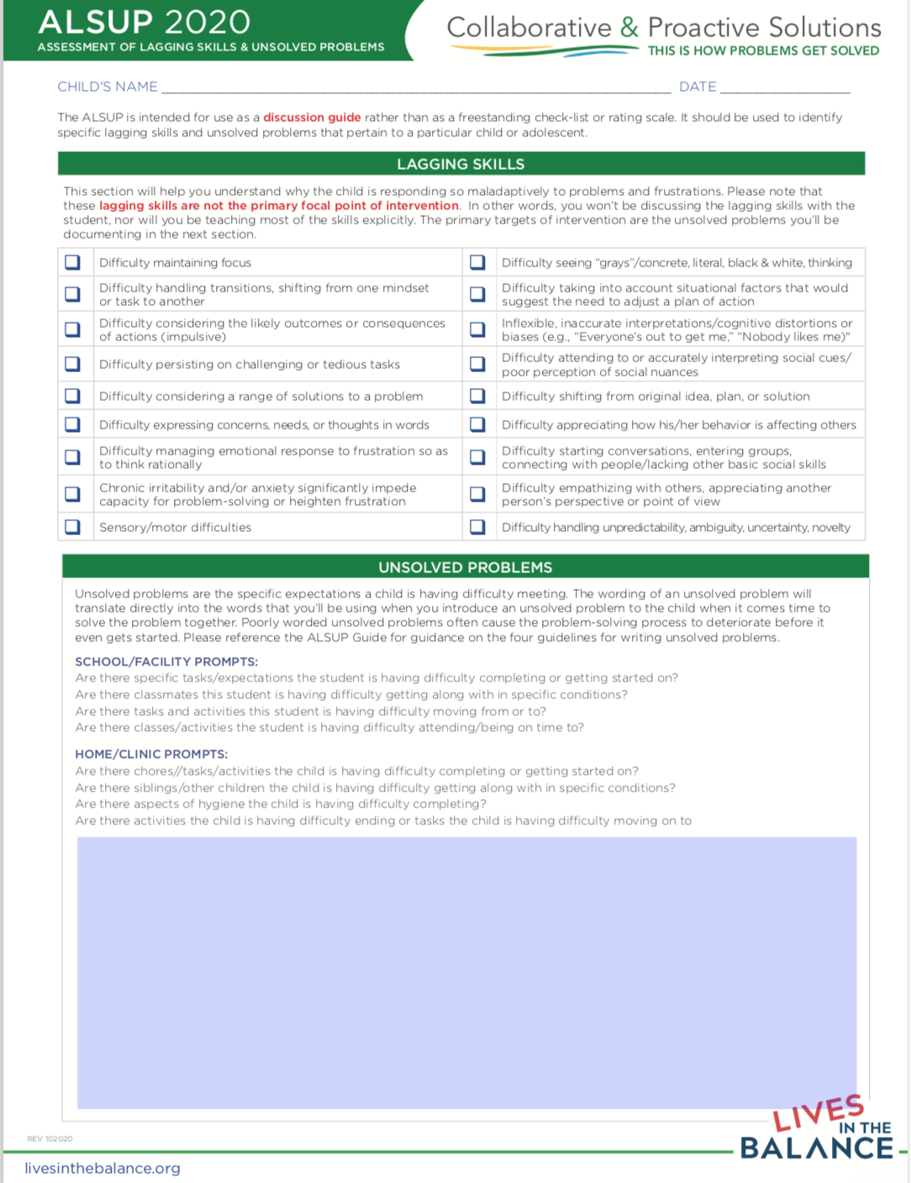
Appendix B. Problem Solving Plan
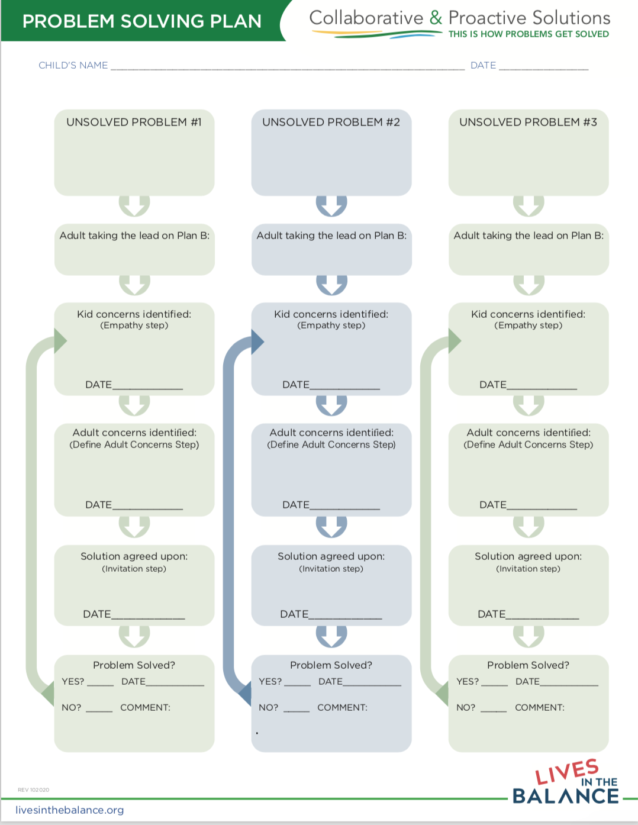
Appendix C. The Plan B Progress Sheet

Student Name:

Date:

Adult Doing Plan B:
Unsolved Problem:
1.Empathy Step:
I’ve noticed ... what’s up? What is getting in your way?
What is it about ________ that is hard for you? Tell me more....
What is making it difficult for the student to meet the expectation. How does _____ make it hard for you to (unsolved problem).
Student Concerns:

2. Define Adult Concern Step:
My concern is:.... (here are my worries when you have difficulty with _____)
How is the student’s difficulty impacting self or others?
Adult Concerns:
3. Invitation Step:
Are you ready to work on solving this problem?
I wonder if there is a way....
Solutions are evaluated one at a time on the basis of whether they are realistic and mutually satisfactory..
Agreed-Upon Solution:

