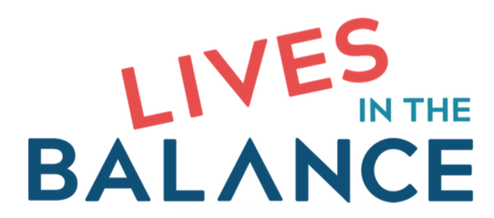
Changing Course
School Discipline Initiative
This initiative provides scholarships to schools for professional development on Collaborative & Proactive Solutions (CPS), the non-punitive, non-adversarial, trauma-informed, evidence-based model originated by Dr. Ross Greene.
Criteria for Selection
Schools will be selected through an application process. Schools meeting any or many of the following criteria will be selected:
- High rates of detention and suspension
- High rates of corporal punishment
- High rates of restraint and/or seclusion
- High rates of disproportionality
The Scholarship
The scholarship will provide a 15-week proficiency training in CPS free of charge to a group of 8-10 staff in selected schools. Participating schools will need to provide discipline data for the two years prior to and two years after the training.
The Training
In our 15-week proficiency training, a Lives in the Balance trainer works with 8-10 staff (known as the “core group”) by Zoom. This training helps key staff become proficient in the two key facets of the CPS model (the Assessment of Lagging Skills and Unsolved Problems [ALSUP] and Plan B), and requires that participants submit work samples to the trainer via Dropbox, and participate in weekly one-hour weekly group coaching and feedback sessions. The goal of the training is to help staff become proficient in using the ALSUP and Plan B so as to model these facets for other staff, thereby facilitating the spread of CPS through the school or facility. The core group is typically comprised of a cross-section of administrators and special and general education classroom teachers. Key prerequisites for participants are (a) an open mind, (b) a willingness to practice the model between sessions, and (c) the courage to receive feedback in a group format.

Application Requirements
The application process must be completed for a school to participate in the project. Applications are accepted year-round and schools are selected on a rolling basis. Schools will be notified by email of their acceptance. An interview with a representative from the school will be part of the selection process. Schools will need to be ready to begin their training within 60 days of receiving acceptance into the scholarship program.
Eligibility
The project is open to schools that identify as public, charter, nonprofit, or private. Schools must also meet the criteria specified above. Preference will be given to schools with at least 40% Black, Latino, and other non-White student population.

